FOOD BANK MANAGEMENT SYSTEM
CONTENT

CHAPTER | TITLE | PAGE.NO
1 | INTRODUCTION  - ABSTRACT
2 | SYSTEM ANALYSIS  - EXISTING SYSTEM  - PROPOSED SYSTEM
3 | Project description
4 | SYSTEM REQUIREMENTS  - HARDWARE REQUIREMENTS  SOFTWARE REQUIREMENTS
5 | Software description
6 | System design  Data flow diagram
7 | SOURCE CODE
8 | SCREEN LAYOUTS
9 | SYSTEM TESTING  - BLACK BOX  - WHITE TEST  - UNIT TEST  - INTEGRATION  - VERIFICATION  - VALIDATION
10 | CONCLUSION
11 | BIBLIOGRAPHY

ABSTRACT
The Food Bank Management System is an innovative software solution designed to streamline the operations of food banks, ensuring effective and efficient management of donated food, distribution to those in need, and overall supply chain management. Food banks play a critical role in supporting underserved communities, but managing food donations, tracking inventory, and coordinating distribution can be a complex and time-consuming task. This system aims to automate and optimize these processes through a user-friendly interface that connects donors, volunteers, and recipients in a centralized, transparent, and accountable manner.
The system primarily focuses on three key aspects:
- Donor Management: Facilitates the registration and tracking of donors, whether they are individuals, organizations, or businesses. It allows donors to schedule donations, track past contributions, and manage communication with the food bank.
2. Inventory Management: The system helps track food donations in real-time, categorizing items based on type, expiration date, and quantity. It ensures that food is appropriately stored, rotated, and disposed of when necessary, helping prevent waste and ensuring that the most nutritious options are distributed to recipients.
3. Reporting and Analytics: The system provides real-time reporting and data analytics, allowing administrators to generate reports on food donations, inventory levels, distribution efforts, and volunteer participation. These insights can aid in decision-making, help plan food drives, and demonstrate the food bank’s impact to stakeholders and funders.

The Food Bank Management System is built with scalability and flexibility in mind, allowing it to be customized based on the unique needs of different food banks. It is designed to work in various environments, whether large urban food banks or small community-based initiatives. With a goal to reduce food waste, increase operational efficiency, and improve accessibility to food for those in need, the system offers a comprehensive solution to modernize food bank operations and ensure that food reaches the people who need it most in a timely and organized manner with low cost for foods.

SYSTEM ANALYSIS

SYSTEM ANALYSIS
EXISTING SYSTEM
The existing systems used in food banks today typically rely on manual processes, disparate software solutions, or basic inventory management tools to manage the distribution of food, donor coordination, volunteer management, and recipient tracking. These systems, while functional, often present several challenges related to inefficiency, lack of real-time data, data integrity issues, and limited scalability.

Current Practice: In many food banks, the tracking of food donations, inventory, and distribution logs is done manually using paper-based records, spreadsheets, or basic database systems.

Food Waste and Expiry Management
- Current Practice: Food banks often manually track food expiration dates and may not have the capability to properly rotate stock to ensure that perishable food is distributed before it spoils.
- Challenges:
  - Waste: Expired or unsellable food may end up being discarded, leading to food waste and loss of resources.
  - Health Risks: Poor management of food storage and expiry can pose risks to recipients’ health, especially if expired or improperly stored food is distributed.
  - No Alerts: Existing systems often do not send automated alerts when food is nearing expiration or needs to be used, leading to operational inefficiencies.

PROPOSED SYSTEM
The Food Bank Management System (FBMS) is a web-based application developed using Django, a Python web framework. The primary goal of this system is to streamline the operations of food banks, including managing donations, tracking inventory, distributing food to recipients, and coordinating volunteers.

Key Features of the Food Bank Management System
- Donor Management:
  - Allows donors to register, view past donations, and track donation history.
  - Donors can specify the type and quantity of food they wish to donate.
  - Donor contact information is stored for easy communication.
2. Inventory Management:
- Tracks food donations by category (e.g., perishable, non-perishable).
- Monitors food quantities, expiration dates, and shelf life.
3. Food Distribution:
- Distributes food based on availability, needs, and priority.
- Real-time tracking of food distributed to recipients.

PROJECT DESCRIPTION

The Food Bank Management System (FBMS) is a web-based application designed to streamline and enhance the operations of food banks. The system leverages modern web technologies, specifically Django (a Python-based web framework), to automate and simplify the critical processes involved in managing food donations, inventory, recipient distribution, and volunteer coordination. This project aims to improve the efficiency, transparency, and accountability of food banks by digitizing operations and providing real-time data analytics.
Food banks are vital organizations that help combat hunger by distributing donated food to individuals and families in need. However, managing these resources—especially as the scale of donations and recipients grows—can become challenging without the right tools. The Food Bank Management System offers a solution by automating essential tasks, improving communication, and providing real-time insights to administrators.
Food banks play a crucial role in alleviating hunger in various communities, relying on donations from individuals, companies, and other organizations. However, managing these donations, tracking inventory, and distributing food to recipients can become cumbersome, especially for large-scale food banks. The FBMS automates and organizes these tasks to improve efficiency, transparency, and communication across all stakeholders involved.

Objectives of the Food Bank Management System
- Efficiency: To automate manual tasks and ensure that food is tracked, stored, and distributed efficiently to minimize waste.
- Transparency: To offer a transparent system where donors, recipients, and volunteers can easily interact with the food bank, track donations, and receive information.
- Accountability: The system allows food banks to maintain detailed records of all transactions, which helps in auditability and reporting.
- Improved Service: To ensure that food is allocated according to the need of the recipients, with the right amount of food delivered to the right people at the right time.
- Sustainability: By minimizing waste and improving inventory management, the system contributes to sustainable practices and better food security.
Challenges Addressed in existing system
- Manual Tracking: The system eliminates the need for paper-based or spreadsheet tracking, reducing errors and improving efficiency.
- Inventory Wastage: By automating inventory management and tracking expiration dates, the system ensures that perishable food items are distributed before they spoil.
- Lack of Coordination: The system helps coordinate between donors, recipients, and volunteers, ensuring smooth operations and timely food distribution.
- Limited Transparency: Real-time dashboards and reporting features provide transparency for all stakeholders, allowing donors and volunteers to see the impact of their contributions.

To overcome that we are creating web-based Food Bank Management System(FBMS).
The Food Bank Management System follows the Model-View-Template (MVT) architecture that Django is based on:
- Model: Represents the database structure and defines data relationships.
- View: Contains the logic that handles user requests and responses.
- Template: The HTML files that render the data sent by views to users.

Technologies Used
- Django (Python): The backend framework for building the application, handling routing, business logic, database management, and security.
- SQLite/MySQL/PostgreSQL: Database management systems to store and manage donor, recipient, volunteer, and inventory data.
- HTML/CSS: Frontend technologies used to design and structure the web pages of the application.
- JavaScript: For enhancing interactivity on the frontend (optional).
- Bootstrap: A front-end framework used to build responsive and user-friendly interfaces (optional).
- Django REST Framework (optional): To build a REST API for mobile apps or third-party integrations.

System Workflow
- Donors sign up and register the food they wish to donate. This information is stored in the system.
- Recipients get their food based on their needs at low cost.

Benefits of the Food Bank Management System
- Efficient Inventory Management: By keeping real-time track of food donations and expiration dates, the system ensures that inventory is rotated effectively, and food is distributed on time.
2. Improved Communication: The system provides a unified platform for communication among donors, volunteers, recipients, and administrators, reducing the likelihood of missed opportunities or confusion.

SYSTEM REQUIREMENTS

SYSTEM REQUIREMENTS
HARDWARE REQUIREMENTS
Device name DESKTOP
Processor Intel(R) Core(TM) i3-3220 CPU @ 3.30GHz 3.29 GHz
Installed RAM 4.00 GB
System type 64-bit operating system, x64-based processor
Keyboard IBM
Mouse IBM

SOFTWARE REQUIREMENTS
Operating System : Windows 10 Basic Edition
Language used : Python
Framework Used : Django
Version : IDLE (Python 3.12)
Database : SQLite
User Interface Design : HTML, JAVASCRIPT
Web Browser : Mozilla, Google Chrome, IE8, OPERA

SOFTWARE DESCRIPTION

Python is a very popular general-purpose interpreted, interactive, object-oriented, and high- level programming language. Python is dynamically-typed and garbage-collected programming language. It was created by Guido van Rossum during 1985- 1990. Like Perl, Python source code is also available under the GNU General Public License (GPL). Python supports multiple programming paradigms, including Procedural, Object Oriented and Functional programming language. Python design philosophy emphasizes code readability with the use of significant indentation. This tutorial gives a complete understanding of Python programming language starting from basic concepts to advanced concepts.
PYTHON FEATURES
- Uses an elegant syntax, making the programs you write easier to read.
- Is an easy-to-use language that makes it simple to get your program working. This makes Python ideal for prototype development and other ad-hoc programming tasks, without compromising maintainability.
- Comes with a large standard library that supports many common programming tasks such as connecting to web servers, searching text with regular expressions, reading and modifying files.
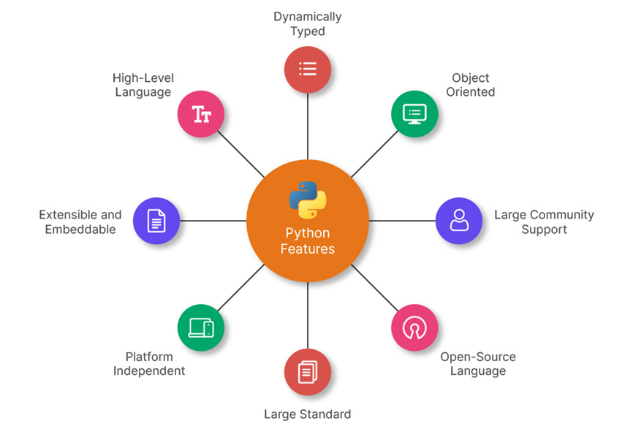
- Python's interactive mode makes it easy to test short snippets of code. There's also a bundled development environment called IDLE.
- Is easily extended by adding new modules implemented in a compiled language such as C or C++.
- Can also be embedded into an application to provide a programmable interface.
- Runs anywhere, including Mac OS X, Windows, Linux, and UNIX, with unofficial builds also available for Android and iOS.
- Is free software in two senses. It doesn't cost anything to download or use Python, or to include it in your application. Python can also be freely modified and re-distributed because while the language is copyrighted it's available under an open-source license.
PYTHON CAREERS
- Game developer
- Web designer
- Python developer
- Full-stack developer
- Machine learning engineer
- Data scientist
- Data analyst
- Data engineer
- DevOps engineer
- Software engineer
- Many more other roles
CHARACTERISTICS OF PYTHON
- It supports functional and structured programming methods as well as OOP.
- It can be used as a scripting language or can be compiled to byte-code for building large applications.
- It provides very high-level dynamic data types and supports dynamic type checking.
- It supports automatic garbage collection.
- It can be easily integrated with C, C++, COM, ActiveX, CORBA, and Java.
PYTHON HISTORY
Guido Van Rossum, a Dutch programmer, created Python programming language. In the late 80's, he had been working on the development of ABC language in a computer science research institute named Centrum Wiskunde & Informatica (CWI) in the Netherlands. In 1991, Van Rossum conceived and published Python as a successor of ABC language. For many uninitiated people, the word Python is related to a species of snake. Rossum though attributes the choice of the name Python to a popular comedy series "Monty Python's Flying Circus" on BBC. Being the principal architect of Python, the developer community conferred upon him the title of "Benevolent Dictator for Life (BDFL). However, in 2018, Rossum relinquished the title. Thereafter, the development and distribution of the reference implementation of Python is handled by a nonprofit organization Python Software Foundation. Important stages in the history of Python: Python 0.9.0 Python's first published version is 0.9. It was released in February 1991. It consisted of support for core object- oriented programming principles. Python 1.0 In January 1994, version 1.0 was released, armed with functional programming tools, features like support for complex numbers etc. Python 2.0 Next major version – Python 2.0 was launched in October 2000.
Many new features such as list comprehension, garbage collection and Unicode support were included with it. Python 3.0 Python 3.0, a completely revamped version of Python was released in December 2008. The primary objective of this revamp was to remove a lot of discrepancies that had crept in Python 2.x versions. Python 3 was backported to Python 2.6. It also included a utility named as python2to3 to facilitate automatic translation of Python 2 code to Python 3. EOL for Python 2.x Even after the release of Python 3, Python Software Foundation continued to support the Python 2 branch with incremental micro versions till 2019. However, it decided to discontinue the support by the end of year 2020, at which time Python 2.
Python Function
A function in Python is a reusable block of code that performs a specific task. It helps to make programs more organized, modular, and efficient.
Key Concepts of Python Functions
- Defining a Function
- Use the def keyword.
- Give the function a name.
- Add parameters (optional) inside parentheses.
- Write the function body with indentation.
- Use return (optional) to output a result.
PYTHON LAMBDA
Python, an anonymous function means that a function is without a name. As we already know that def keyword is used to define the normal functions and the lambda keyword is used to create anonymous functions.
Python lambda Syntax:
lambda arguments : expression Python lambda properties:
- This function can have any number of arguments but only one expression, which is evaluated and returned.
- One is free to use lambda functions wherever function objects are required.
- You need to keep in your knowledge that lambda functions are syntactically restricted to a single expression.
- It has various uses in particular fields of programming, besides other types of expressions in functions.

Python input() Function
Python input() function is used to take user input. By default, it returns the user input in form of a string.
input() Function
Syntax:
input(prompt)
prompt [optional]: any string value to display as input message7.17 was the last version in the branch.
Python Modules
The concept of module in Python further enhances the modularity. You can define more than one related functions together and load required functions. A module is a file containing definition of functions, classes, variables, constants or any other Python object. Contents of this file can be made available to any other program. Python has the import keyword for this purpose.
Python GUI (Graphical User Interface) Concept
A GUI (Graphical User Interface) in Python allows users to interact with programs visually using buttons, menus, windows, and other graphical components instead of the command line. Python offers multiple GUI frameworks to build interactive applications.
1. Popular Python GUI Frameworks
Framework | Description
Tkinter | Built-in Python library for basic GUI development.
PyQt / PySide | Advanced GUI development using Qt framework.  Kivy Used for multi-touch applications and mobile app development.
PyGTK | GUI framework based on GTK (used in Linux applications).
WxPython | Cross-platform GUI toolkit with a native look.

2. Basic Structure of a Python GUI Application (Using Tkinter)
- Steps to Create a Simple GUI
- Import the GUI library.
- Create the main application window.
- Add widgets (buttons, labels, text boxes, etc.).
- Define event handling (what happens when a user interacts).
- Run the application loop.
- 3. Key GUI Components (Widgets)
Widget | Description
Label | Displays text or images.
Button | Triggers an action when clicked.
Entry | Text input field.
Text | Multi-line text input.
Frame | Container to hold widgets.
Canvas | Draw shapes, images, or graphs.
Checkbutton | Checkbox for selection.
Radiobutton | Choose one option from multiple choices.
Listbox | Displays a list of selectable items.
Menu | Dropdown menus for navigation.

4. Advanced GUI Features
- Using Frames and Layouts (Grid, Pack, Place)
- Working with Images and Icons (PIL for image handling)
- Creating Dialog Boxes & Message Pop-ups (messagebox)
- Building Multi-Page Applications (ttk.Notebook)
- Styling with Themes (ttk module)
Python Django
Django, built with Python, is designed to help developers build secure, scalable, and feature-rich web applications quickly and efficiently. Whether you’re a beginner looking to create your first dynamic website or an experienced developer aiming to enhance your skills, this tutorial will guide you through Django’s core concepts.

This also tutorial provides you with Django projects to help you apply your knowledge and build some cool web applications. These projects not only provide you with experience in building with the Django framework but will also add value to your resume. This Python Django tutorial teaches basic to advanced Django concepts for backend development. Learn topics like forms, templates, views, ORM, etc.

Django History
Django was created in the autumn of 2003, when the web programmers at the Lawrence Journal-World newspaper, Adrian Holovaty and Simon Willison, began using Python to build applications. Jacob Kaplan-Moss was hired early in Django's development shortly before Willison's internship ended. It was released publicly under a BSD license in July 2005. The framework was named after guitarist Django Reinhardt. Holovaty is a Romani jazz guitar player inspired in part by Reinhardt's music. In June 2008, it was announced that a newly formed Django Software Foundation (DSF) would maintain Django in the future.

Features of Django
- Rapid Development: Django’s DRY principle accelerates development by reducing code repetition.
- Admin Interface: Comes with a ready-to-use, customizable admin panel for easy backend management.
- Scalable: Built to handle high traffic and complex applications, ideal for projects of any size.
- Security: Offers built-in protections against common security threats like XSS, CSRF, and SQL injection.
- ORM: Simplifies database interaction using Python, eliminating the need for raw SQL.
- URL Routing: Clean, readable URLs with easy mapping to views.
- Template Engine: Separates logic from presentation for dynamic, reusable web pages.
- Extensive Documentation: Well-organized resources for troubleshooting and learning.
- Active Community: Large community support with abundant third-party plugins and tools.
Virtual environment
A Python Virtual Environment is an isolated space where you can work on your Python projects, separately from your system-installed Python. You can set up your own libraries and dependencies without affecting the system Python. We will use virtualenv to create a virtual environment in Python.
Create Virtual Environment in Python
We use a module named virtualenv which is a tool to create virtual environment Python, isolated from the system environment Python.
INTRODUCTION TO SQLITE
SQLite is an in-process library that implements a self-contained, serverless, zero- configuration, transactional SQL database engine. It is a popular choice as an embedded database for local/client storage in application software such as web browsers. It is also used in many other applications that need a lightweight, embedded database.
SQLite is ACID-compliant and implements most of the SQL standards, using a dynamically and weakly typed SQL syntax that does not guarantee domain integrity.
To use SQLite in a C/C++ program, you can use the sqlite3 API, which provides a lightweight, simple, self-contained, high-reliability, full-featured, and SQL database engine. The API is implemented as a library of C functions that can be called from your program. One of the main benefits of using SQLite is that it is very easy to get started with.
SQLite History
SQLite was created in the year 2000 by D. Richard Hipp, who continues to lead the development of the software today. SQLite was designed to be a lightweight and simple database engine that could be easily embedded into other applications. It was created as an alternative to more complex and heavyweight database engines, such as MySQL and PostgreSQL. Over the years, SQLite has gained widespread adoption and is now one of the most widely used database engines in the world. It is used in many applications, including web browsers, mobile phones, and a wide variety of other software.
SQLite is an open-source software project, and the source code is available under the terms of the SQLite license, which is a permissive, public domain-like license. This has contributed to its widespread adoption, as developers are free to use and modify the source code as they see fit.

Why SQLite?
- Ease of use: SQLite is very easy to get started with, as it requires no setup or configuration. You can simply include the library in your project and start using it.
- Embeddability: SQLite is designed to be embedded into other applications. It is a self- contained, serverless database engine, which means you can include it in your application without the need for a separate database server.
- Lightweight: SQLite is a very lightweight database engine, with a small library size (typically less than 1MB). This makes it well-suited for use in applications where the database is embedded directly into the application binary, such as mobile apps.
- Serverless: As mentioned earlier, SQLite is a serverless database engine, which means there is no need to set up and maintain a separate database server process. This makes it easy to deploy and manage, as there are no additional dependencies to worry about.
- Cross-platform: SQLite is available on many platforms, including Linux, macOS, and Windows, making it a good choice for cross-platform development.
- Standalone: SQLite stores all of the data in a single file on the filesystem, which makes it easy to copy or backup the database.
- High reliability: SQLite has been widely tested and used in production systems for many years, and has a reputation for being a reliable and robust database engine.

Features of SQLite
- The transactions follow ACID properties i.e. atomicity, consistency, isolation, and durability even after system crashes and power failures.
- The configuration process is very easy, no setup or administration is needed.
- All the features of SQL are implemented in it with some additional features like partial indexes, indexes on expressions, JSON, and common table expressions.
- Sometimes it is faster than the direct file system I/O.
- It supports terabyte-sized databases and gigabyte-sized strings and blobs.
- Almost all OS supports SQLite like Android, BSD, iOS, Linux, Mac, Solaris, VxWorks, and Windows (Win32, WinCE, etc. It is very much easy to port to other systems.
- A complete database can be stored in a single cross-platform disk file.Applications of SQLite
- Due to its small code print and efficient usage of memory, it is the popular choice for the database engine in cell phones, PDAs, MP3 players, set-top boxes, and other electronic gadgets.
- It is used as an alternative for open to writing XML, JSON, CSV, or some proprietary format into disk files used by the application.
- As it has no complication for configuration and easily stores file in an ordinary disk file, so it can be used as a database for small to medium sized websites.
- It is faster and accessible through a wide variety of third-party tools, so it has great applications in different software platforms.

Difference between MySQL and SQLite:

S.NO. | MySQL | SQLite
1. | Released by MySQL AB on May 1995. Developed by Oracle since 2010. | Developed By D. Richard Hipp on August 2000.
2. | MySQL is developed in C and C++ languages. | SQLite is developed only in C language.
3. | MySQL requires a database server for its functioning. Hence, it follows client/server architecture. | SQLite does not require a server to run. Hence, it is serverless.
4. | It can handle multiple connections simultaneously. | It can handle only one connection at a time.
5. | It is highly scalable and can handle a large volume of data very efficiently. | It can handle only small set of data if the volume of data increased its performance degrades.
6. | It requires large space in the memory for its functioning (approx 600 Mb). | It requires only some KBs of space as it is very lightweight approx (250Kb- 300Kb).
7. | MySQL supports multiple user environment. | SQLite does not support multiple user environment.
8. | It also supports XML format. | It does not supports XML format.
9 | MySQL is licensed under the GNU General Public License which means it is open source and free to use | SQLite is in the public domain and can be used without any licensing restrictions.

system design

DATAFLOW DIAGRAM

FOOD BANK MANAGEMENT
CREATE POST
USER
VIEW POST
CUSTOMER
RECEIVE FOOD
ORDER FOOD
REGISTER
NEW USER

DATABASE DESIGN
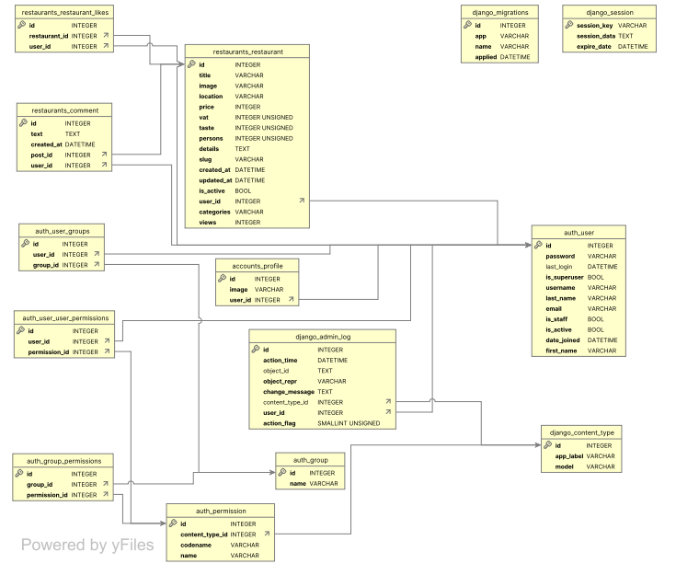

SOURCE CODE

SOURCE CODE:
#coding in manage.py
#!/usr/bin/env python
import os
import sys

if __name__ == '__main__':
os.environ.setdefault('DJANGO_SETTINGS_MODULE', 'FoodBank.settings')
try:
from django.core.management import execute_from_command_line
except ImportError as exc:
raise ImportError(
"Couldn't import Django. Are you sure it's installed and "
"available on your PYTHONPATH environment variable? Did you "
"forget to activate a virtual environment?"
) from exc
execute_from_command_line(sys.argv)
#coding in settings.py
import os

# Build paths inside the project like this: os.path.join(BASE_DIR, ...)
BASE_DIR = os.path.dirname(os.path.dirname(os.path.abspath(__file__)))

# Quick-start development settings - unsuitable for production
# See https://docs.djangoproject.com/en/2.1/howto/deployment/checklist/

# SECURITY WARNING: keep the secret key used in production secret!
SECRET_KEY = 'p#xylf*v67dvw^1k#yv@ie!xlzdqo8$1j96$4hmk2#@q*#w6yc'

# SECURITY WARNING: don't run with debug turned on in production!
DEBUG = True

ALLOWED_HOSTS = []

# Application definition

INSTALLED_APPS = [
'django.contrib.admin',
'django.contrib.auth',
'django.contrib.contenttypes',
'django.contrib.sessions',
'django.contrib.messages',
'django.contrib.staticfiles',
'django.contrib.humanize',
'restaurants.apps.RestaurantsConfig',
'accounts.apps.AccountsConfig',
]

MIDDLEWARE = [
'django.middleware.security.SecurityMiddleware',
'django.contrib.sessions.middleware.SessionMiddleware',
'django.middleware.common.CommonMiddleware',
'django.middleware.csrf.CsrfViewMiddleware',
'django.contrib.auth.middleware.AuthenticationMiddleware',
'django.contrib.messages.middleware.MessageMiddleware',
'django.middleware.clickjacking.XFrameOptionsMiddleware',
]

ROOT_URLCONF = 'FoodBank.urls'

TEMPLATES = [
{
'BACKEND': 'django.template.backends.django.DjangoTemplates',
'DIRS': [os.path.join(BASE_DIR, 'templates')],
'APP_DIRS': True,
'OPTIONS': {
'context_processors': [
'django.template.context_processors.debug',
'django.template.context_processors.request',
'django.contrib.auth.context_processors.auth',
'django.contrib.messages.context_processors.messages',
'restaurants.context_processor.categories',
'restaurants.context_processor.user_liked_posts',
'restaurants.context_processor.recent_posts',

],
},
},
]

WSGI_APPLICATION = 'FoodBank.wsgi.application'

# Database
# https://docs.djangoproject.com/en/2.1/ref/settings/#databases

DATABASES = {
'default': {
'ENGINE': 'django.db.backends.sqlite3',
'NAME': os.path.join(BASE_DIR, 'db.sqlite3'),
}
}

# Password validation
# https://docs.djangoproject.com/en/2.1/ref/settings/#auth-password-validators

AUTH_PASSWORD_VALIDATORS = [
{
'NAME': 'django.contrib.auth.password_validation.UserAttributeSimilarityValidator',
},
{
'NAME': 'django.contrib.auth.password_validation.MinimumLengthValidator',
},
{
'NAME': 'django.contrib.auth.password_validation.CommonPasswordValidator',
},
{
'NAME': 'django.contrib.auth.password_validation.NumericPasswordValidator',
},
]

# Internationalization
# https://docs.djangoproject.com/en/2.1/topics/i18n/

LANGUAGE_CODE = 'en-us'

TIME_ZONE = 'UTC'

USE_I18N = True

USE_L10N = True

USE_TZ = True

# Static files (CSS, JavaScript, Images)
# https://docs.djangoproject.com/en/2.1/howto/static-files/

STATIC_URL = '/static/'
STATICFILES_DIRS = [
os.path.join(BASE_DIR, 'static'),
]

MEDIA_ROOT = os.path.join(BASE_DIR, 'media')
MEDIA_URL = '/media/'

LOGIN_REDIRECT_URL = 'my_posts'

# Email configuration
EMAIL_BACKEND = 'django.core.mail.backends.smtp.EmailBackend'
EMAIL_HOST = 'smtp.gmail.com'
EMAIL_PORT = 587
EMAIL_USE_TLS = True
EMAIL_HOST_USER = 'Your email'
EMAIL_HOST_PASSWORD = 'your email password'
#coding in urls.py
from django.conf import settings
from django.conf.urls.static import static
from django.contrib import admin
from django.urls import path, include

urlpatterns = [
path('admin/', admin.site.urls),
path('', include('restaurants.urls')),
path('accounts/', include('accounts.urls')),

]

if settings.DEBUG:
urlpatterns += static(settings.MEDIA_URL,document_root=settings.MEDIA_ROOT)

SCREEN LAYOUTS:
FOOD BANK MANAGEMENT SYSTEM

Step:1
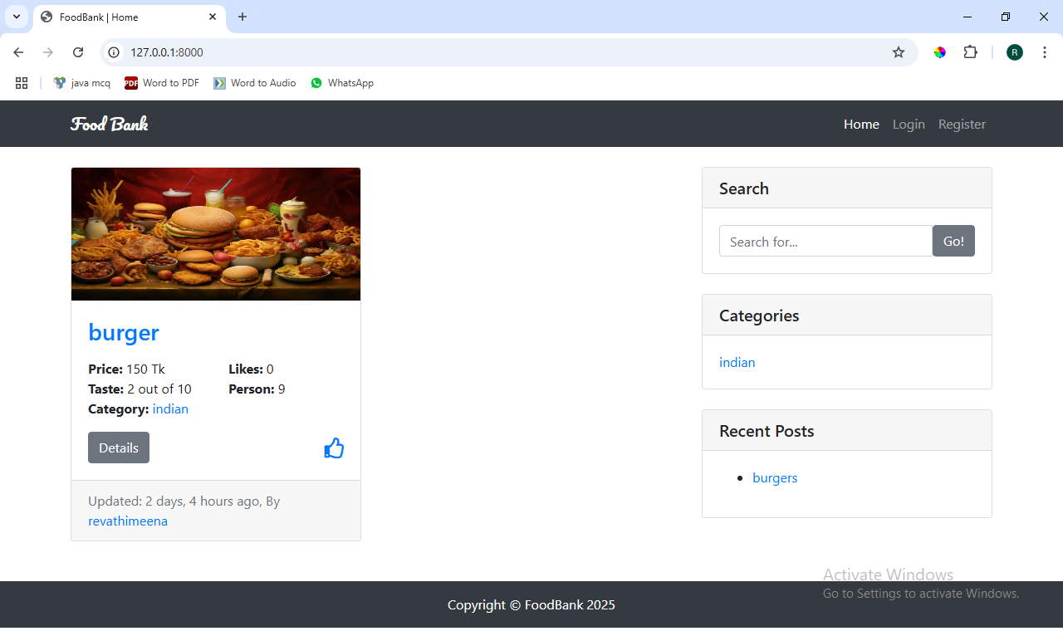

Step:2
Click On “LOGIN PAGE”
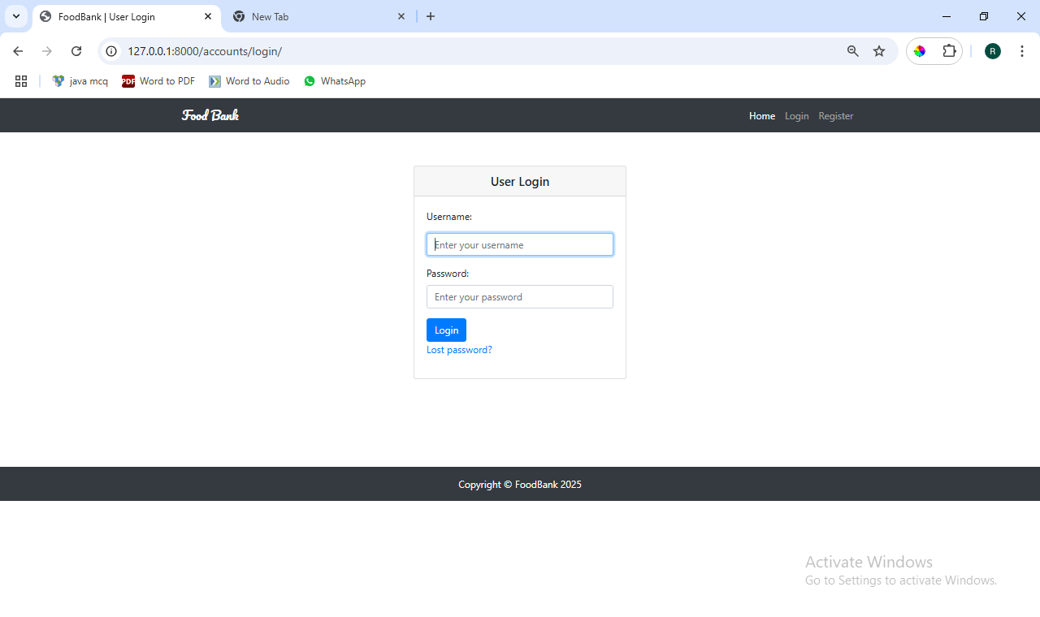

Step:3
Click On “REGISTER”
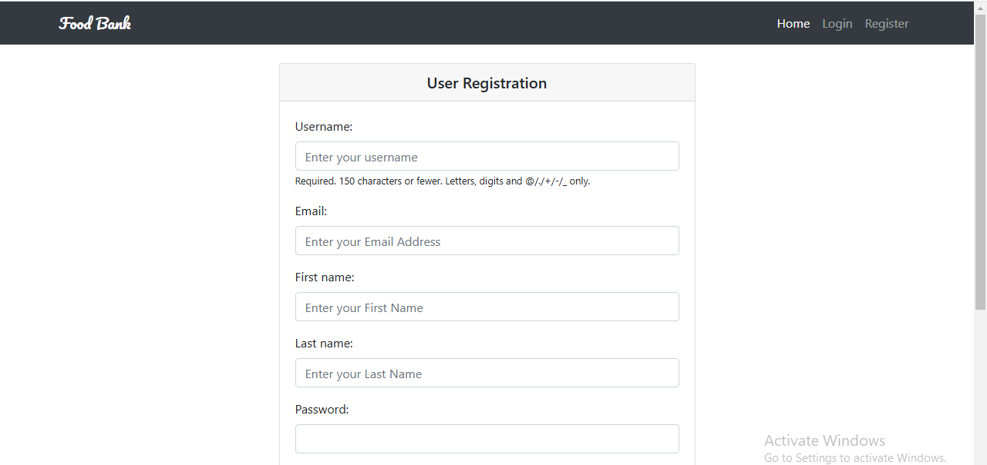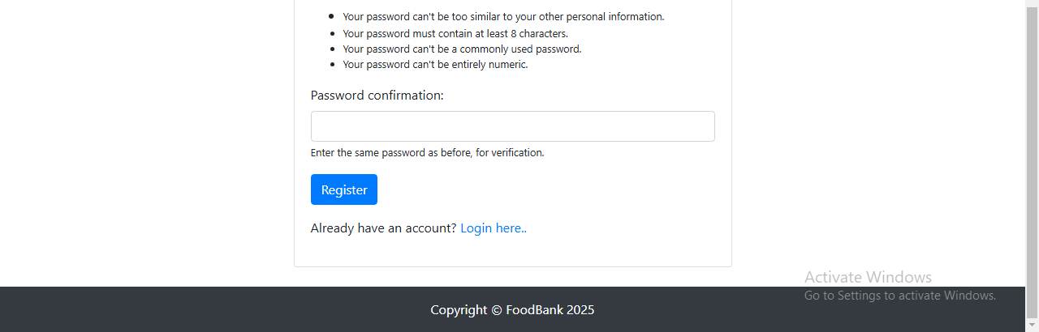

Step: 4

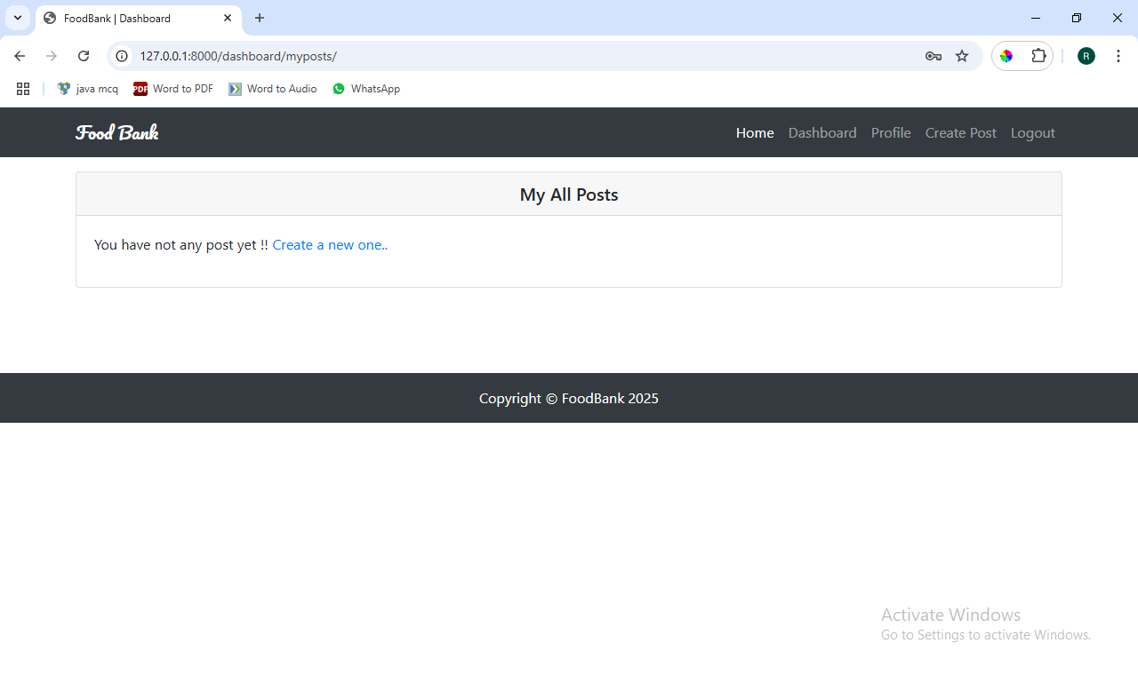

Step: 5
Click on “PROFILE”
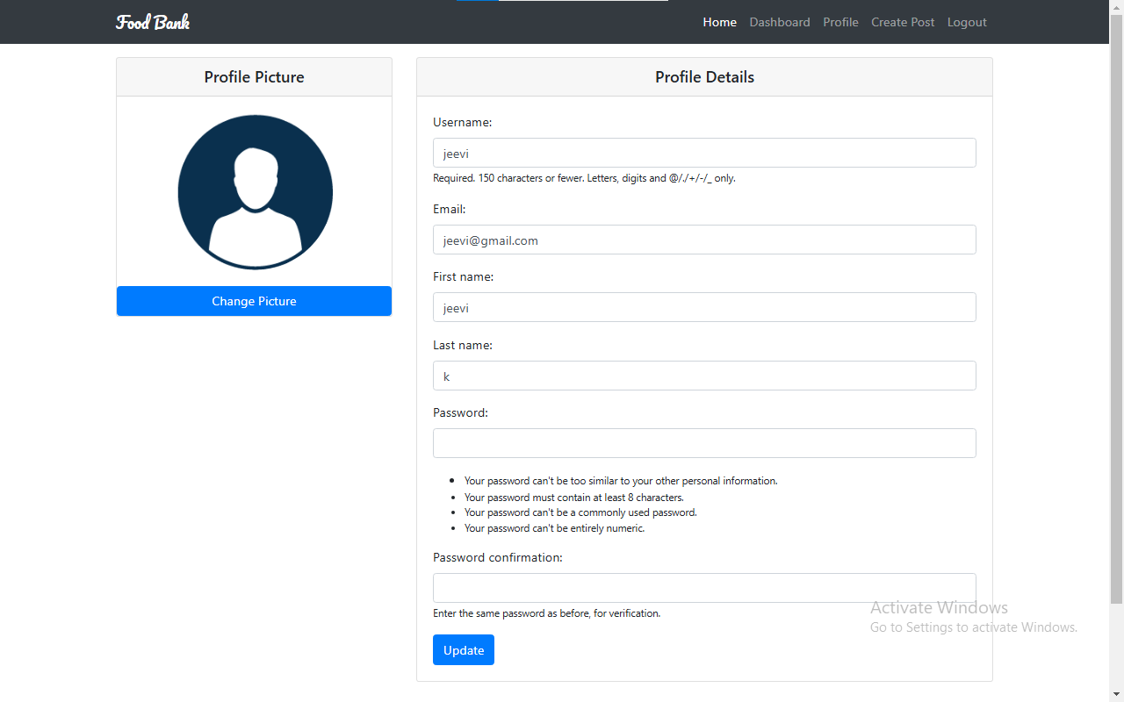

Step: 6
Click on “CREATE POST”
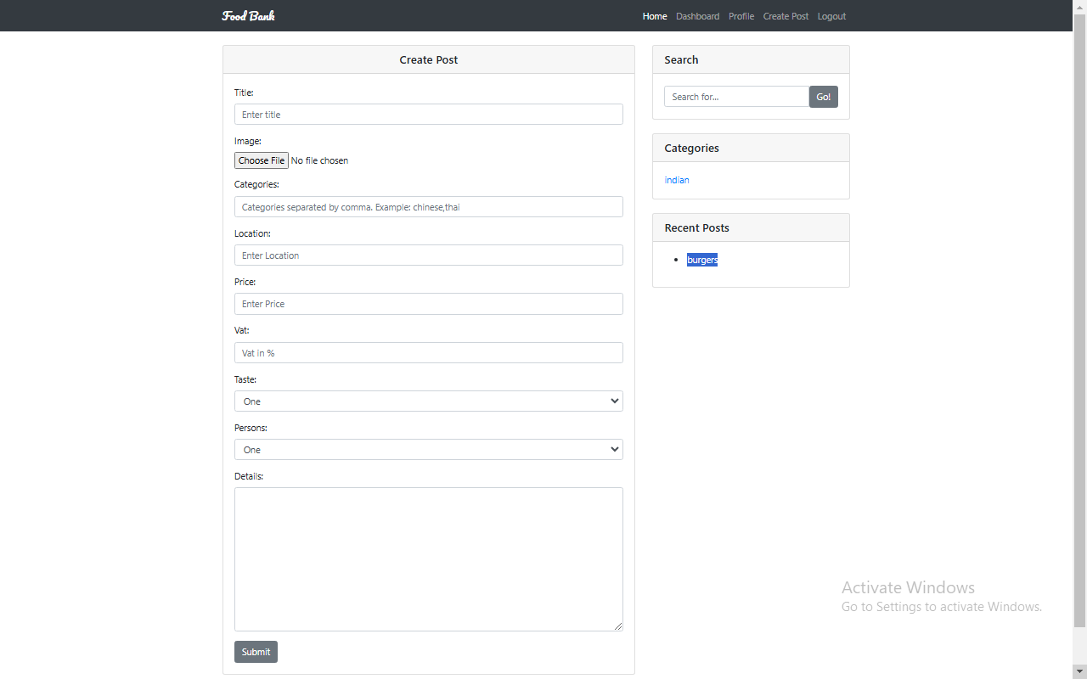

Step: 7
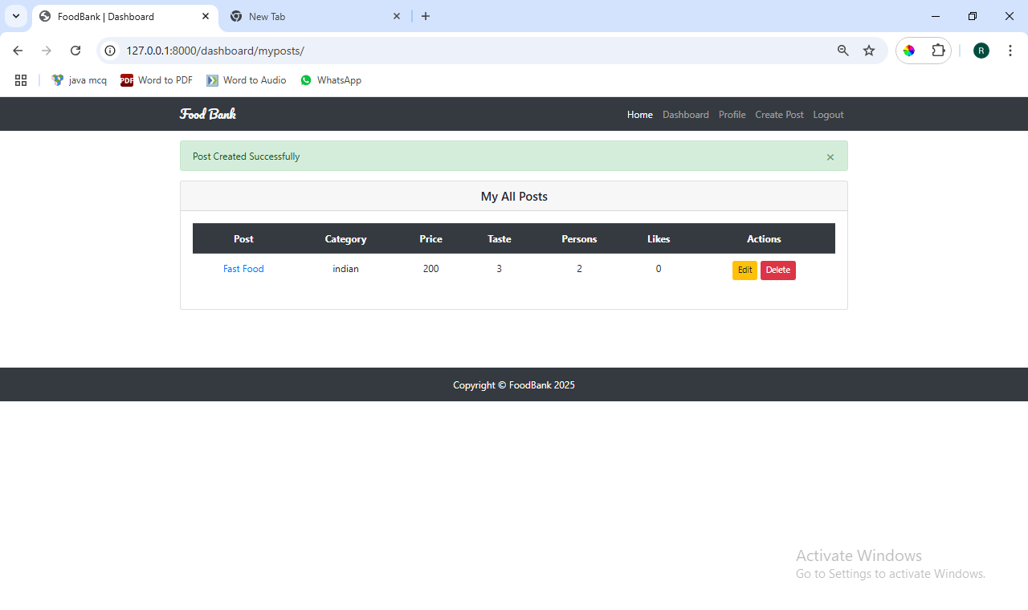

Step: 8
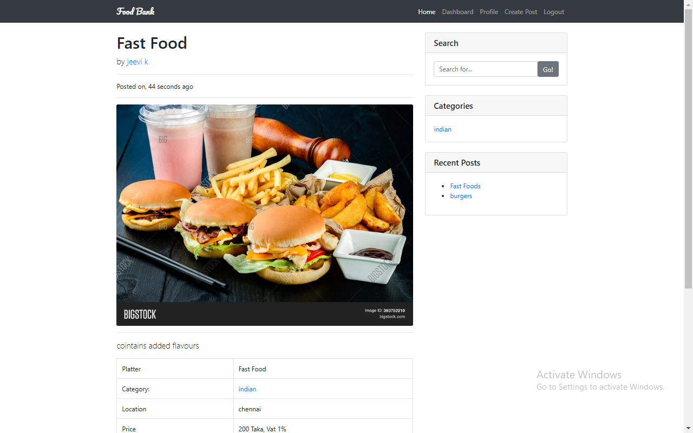

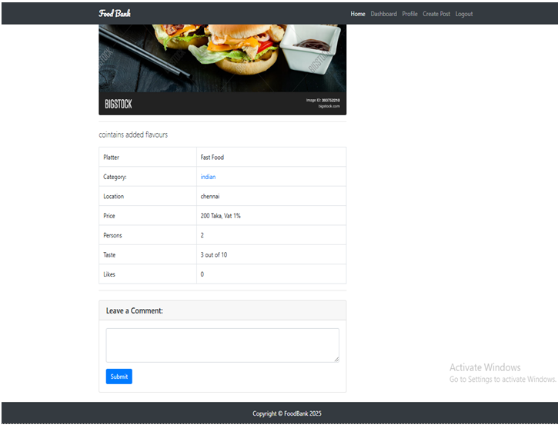

Step: 9
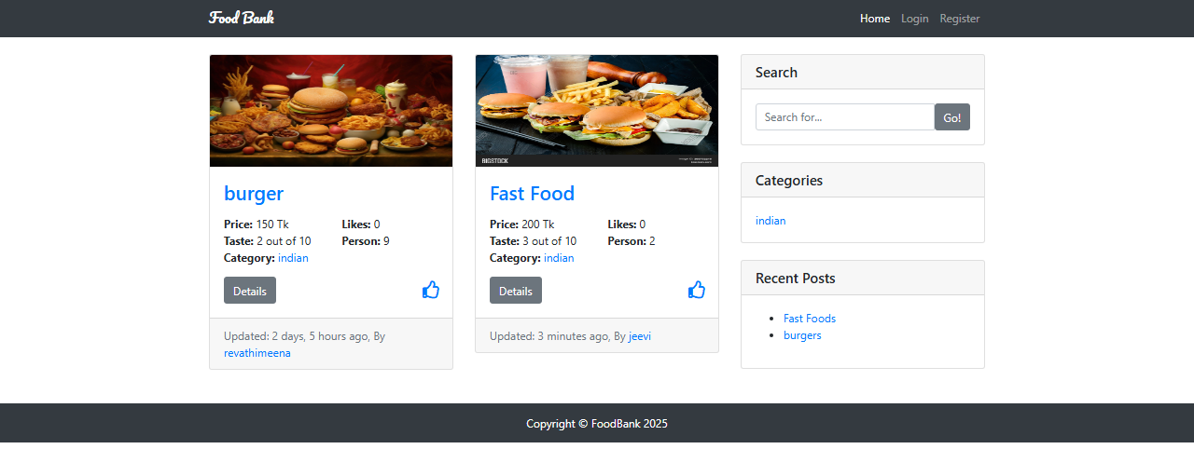

SYSTEM TESTING

SYSTEM TESTING

System testing is a comprehensive testing process that evaluates the complete and integrated software system to verify that it meets specified requirements. It involves testing the software's functionality, reliability, and performance as a whole, rather than individual components, to ensure overall system quality and effectiveness.

It is indeed typically accomplished by software testing engineers. Its performance occurs in a context comparable to the one used in production, permitting the developers and other relevant parties to analyze user responses.

There are four levels of software testing: unit testing, integration testing, system testing and acceptance testing, all are used for the testing purpose. Unit Testing used to test a single software; Integration Testing used to test a group of units of software, System Testing used to test a whole system and Acceptance Testing used to test the acceptability of business requirements. Here we are discussing system testing which is the third level of testing levels.

The below flowchart shows where the System testing happens in the software development life-cycle.
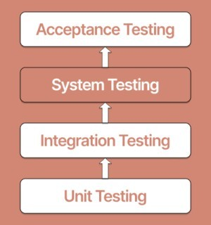

It is important to follow a order when testing software. Following is a chronologically organized list of software testing categories.
Unit testing - During development, each module or block of code is subjected to unit testing. Most of the time, the programmer who writes the code is responsible for unit testing.
Integration- It occurs before, during, and after integrating a new module into the main software package. This includes testing each code module. A single piece of software may comprise various modules, which are
System- A hiogh skilled software performs system testing on the software applicationbefore it is released to the general
Acceptance- acceptance and beta of the software are performed by real end.
There are mainly two widely used methods for software testing, one is White box testing which uses internal coding to design test cases and another is black box testing which uses GUI or user perspective to develop test cases.
- White box testing
- Black box testing
System testing falls under Black box testing as it includes testing of the external working of the software. Testing follows user's perspective to identify minor defects.

System Testing includes the following steps.

  - Verification of input functions of the application to test whether it is producing the expected output or not.
  - Testing of integrated software by including external peripherals to check the interaction of various components with each other.
  - Testing of the whole system for End to End testing.
  - Behaviour testing of the application via a user's experience

SYSTEM TESTING IMPORTANCE
- System Testing gives hundred percent assurance of system performance as it covers end to end function of the system.
- It includes testing of System software architecture and business requirements.
- It helps in mitigating live issues and bugs even after production.
System testing uses both existing system and a new system to feed same data in both and then compare the differences in functionalities of added and existing functions so, the user can understand benefits of new added functions of the system.

CONCLUSION

CONCLUSION
The Food Bank Management System, developed using Django, offers a robust, efficient, and scalable solution for managing the collection, distribution, and tracking of food donations to those in need. By leveraging Django’s powerful features such as its built-in admin interface, secure authentication, and a structured approach to database management, the system ensures a smooth operation for both volunteers and administrators.
Key features include the ability to register and track donors and recipients, manage food inventory, and generate reports on food distribution. The system also provides users with the ability to request or donate food, and administrators can monitor donations and make informed decisions based on data-driven insights.
In conclusion, the Food Bank Management System enhances operational efficiency, improves transparency, and ensures that food donations reach the people who need them most. It reduces the manual burden on staff, minimizes the chances of errors, and optimizes the overall process. The Django framework has proven to be an excellent choice for creating a secure, maintainable, and user-friendly application that can be easily scaled as the needs of the food bank grow.

BIBLIOGRAPHY

BIBLIOGRAPHY:
1. Kumar, R. (2020). Web Development with Django: A Comprehensive Guide. New Delhi: Tech Publishers.
2. Taylor, W. (2019). Mastering Django: Advanced Web Development with Python. New York: O'Reilly Media.
3. Meyers, B. (2020). SQLite for Beginners: A Comprehensive Guide to SQLite with Python. Mumbai: Code Academy Press.
WEBSITES REFERED
https://docs.python.org
https://www.sqlite.org/

